Example 16:

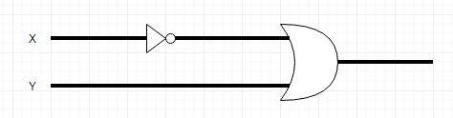 Using Negation-gate and an Or-gate, draw a circuit diagram with input/output behavior of the implication operator.

Example 17:

For each of the following, produce a circuit diagram. Implication operators must be done as above.

1. (a or (b and not(a)) or (not(a or b))

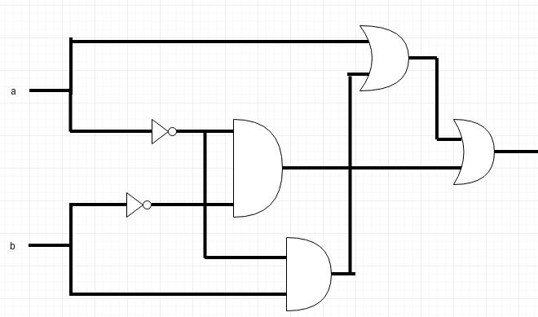

1. ((not a) and (not b)) and (b and (not c))

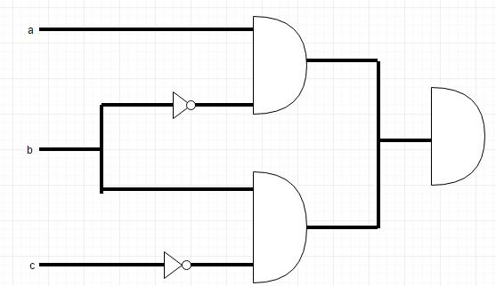

1. a implies (b implies c)

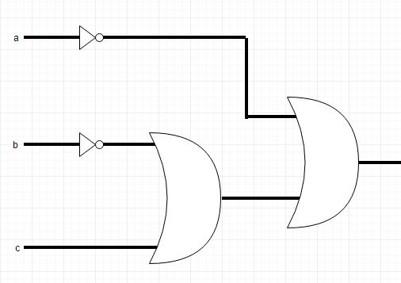

1. (a and b) implies c

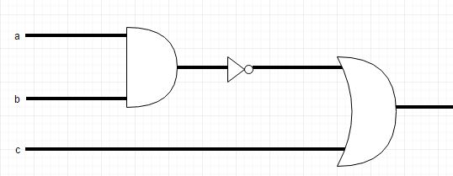

Example 18:

Rewrite each formula above using algebraic notation used by electrical engineers

1. (a + (b)) + ()
2. ()(b)
3. + ( + c)
4. + ) + c

Example 19:

Build circuits that perform the AND-gate, OR-gate, and NOT-gate functions without using the gates themselves

1. AND

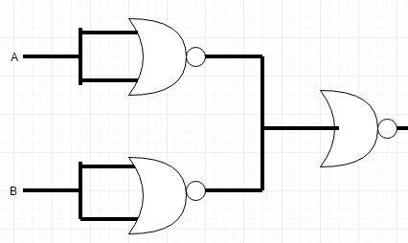

1. OR

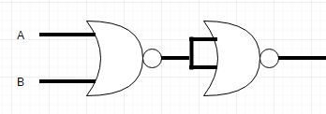

1. NOT

